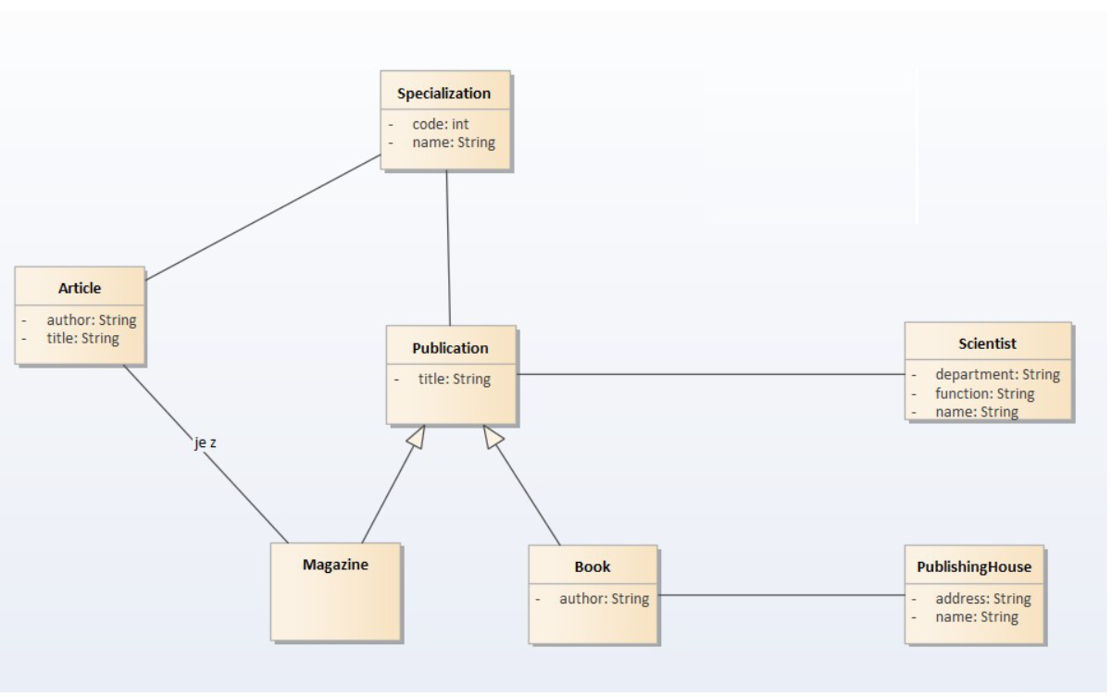

1. Problems

* There is no cardinality.
* Magazine has no attribute which raises questions about its usefulness, instead maybe add an author attribute or some attributes that makes it useful.
* “Je z” means “is from” which is not useful if we use cardinality.
* Articles should have an author.

1. Modifications

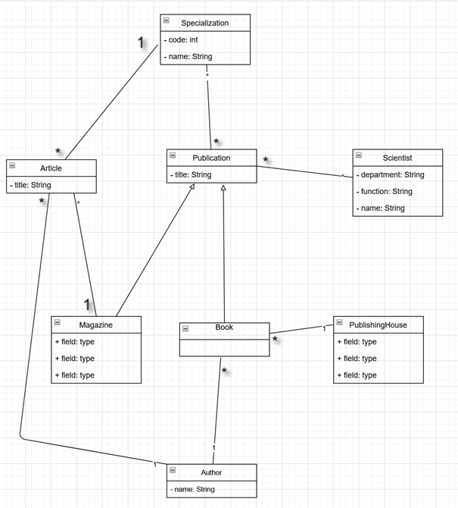

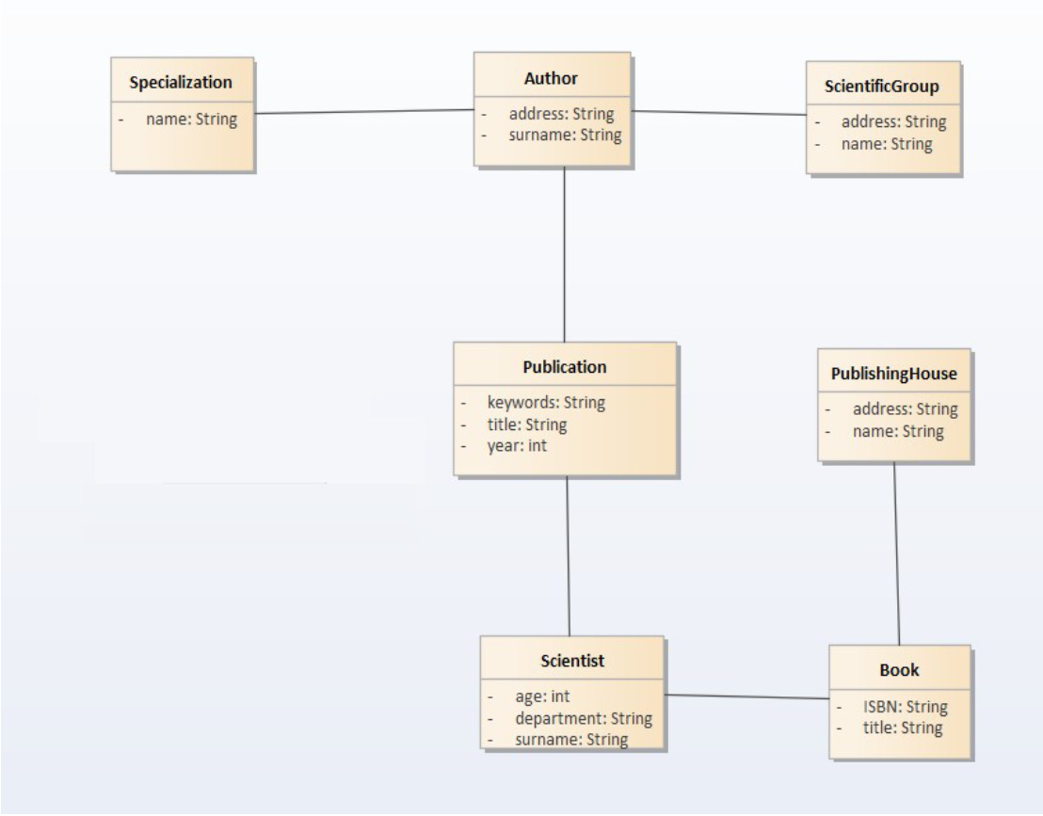

1. Identify problems

* There is no cardinality
* Book can easily be a subclass of Publication
* Scientist should be linked to ScientificGroup
* Specialization is better suited for a publication than an Author.
* Author and Scientist don’t have a name

1. Modifications

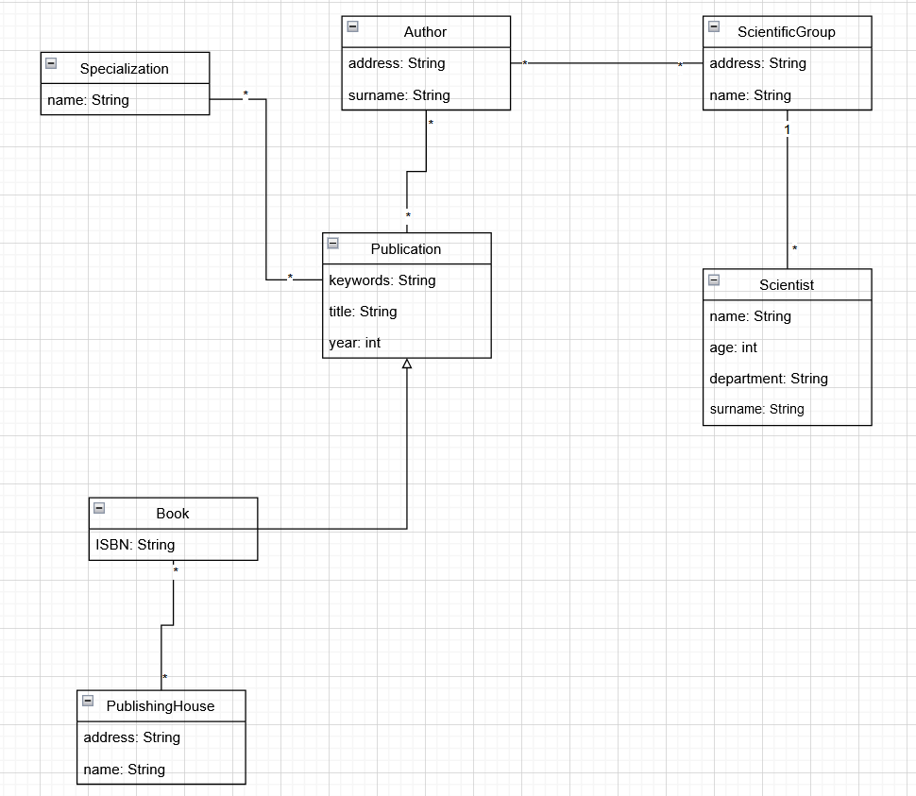

Merge:

